**Background**

*This is a capstone project for the Google Data Analytics Certification. Below is the business background & scenario detailed in the project instruction.*

“In 2016, Cyclistic launched a successful bike-share offering. Since then, the program has grown to a fleet of 5,824 bicycles that are geotracked and locked into a network of 692 stations across Chicago. The bikes can be unlocked from one station and returned to any other station in the system anytime.”

“Until now, Cyclistic’s marketing strategy relied on building general awareness and appealing to broad consumer segments. One approach that helped make these things possible was the flexibility of its pricing plans: single-ride passes, full-day passes, and annual memberships. Customers who purchase single-ride or full-day passes are referred to as casual riders. Customers who purchase annual memberships are Cyclistic members.”

“Cyclistic’s finance analysts have concluded that annual members are much more profitable than casual riders. Although the pricing flexibility helps Cyclistic attract more customers, Moreno believes that maximizing the number of annual members will be key to future growth. Rather than creating a marketing campaign that targets all-new customers, Moreno believes there is a very good chance to convert casual riders into members. She notes that casual riders are already aware of the Cyclistic program and have chosen Cyclistic for their mobility needs.”

**Scenario**

“You are a junior data analyst working in the marketing analyst team at Cyclistic, a bike-share company in Chicago. The director of marketing believes the company’s future success depends on maximizing the number of annual memberships. Therefore, your team wants to understand how casual riders and annual members use Cyclistic bikes differently. From these insights, your team will design a new marketing strategy to convert casual riders into annual members. But first, Cyclistic executives must approve your recommendations, so they must be backed up with compelling data insights and professional data visualizations.”

**Business Task:**

* Analyze rider’s usage patterns for marketing membership conversion programs

**Tools**: R for Data Cleaning and Analysis | Tableau for Data Visualization

**Dataset**: [Cyclistic’sTrip Data from April 2021 to April 2022](https://divvy-tripdata.s3.amazonaws.com/index.html)

**R Code** used in this project can be found [Here](https://github.com/daviddistefano10/Cyclstic.git)

**Tableau** visuals used in this project can be found [Here](https://public.tableau.com/app/profile/david.distefano)

**Analysis of Data:**

**Key Takeaways Between Casual Riders & Members:**

1. The average trip duration for Casual riders is 2.12 times the average trip duration for Members. Whereas members accounted for 1.24x the amount of total rides than casual riders.
2. Total rides for casual riders and members drastically increase in the spring and summer months, peaking in July. And significantly drops off in the late fall and winter.
3. Trip duration for Casual riders peaks during weekends (Friday through Sunday), and levels off during the weekdays. Members maintain uniform activity levels throughout the week
4. Casual riders predominantly frequented sightseeing locations, while members took trips to various areas in the city, mainly near office buildings.

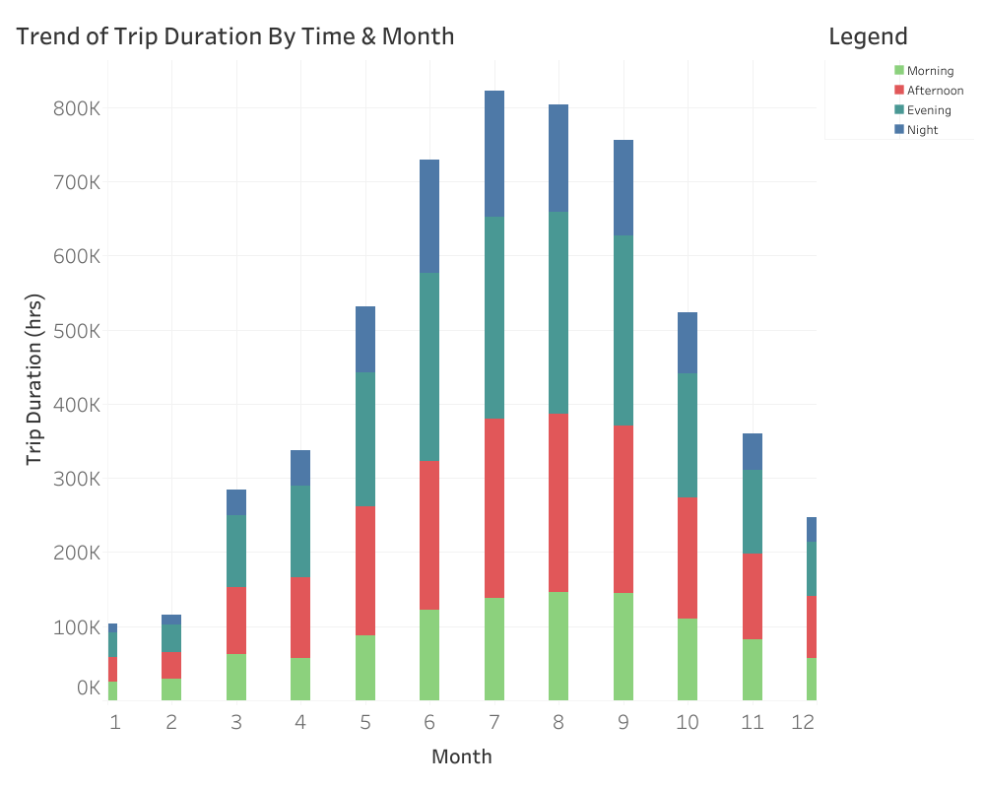

* *Note that month 1-12 corresponds from January (1) to December (12)
* Overall trip duration between casual riders and members.
* Ride usage steadily increases in the spring, and then peaks in the summer months, , while sharply declining in the colder months
* A significant amount of ride usage happens in the Afternoon and Evening hours.

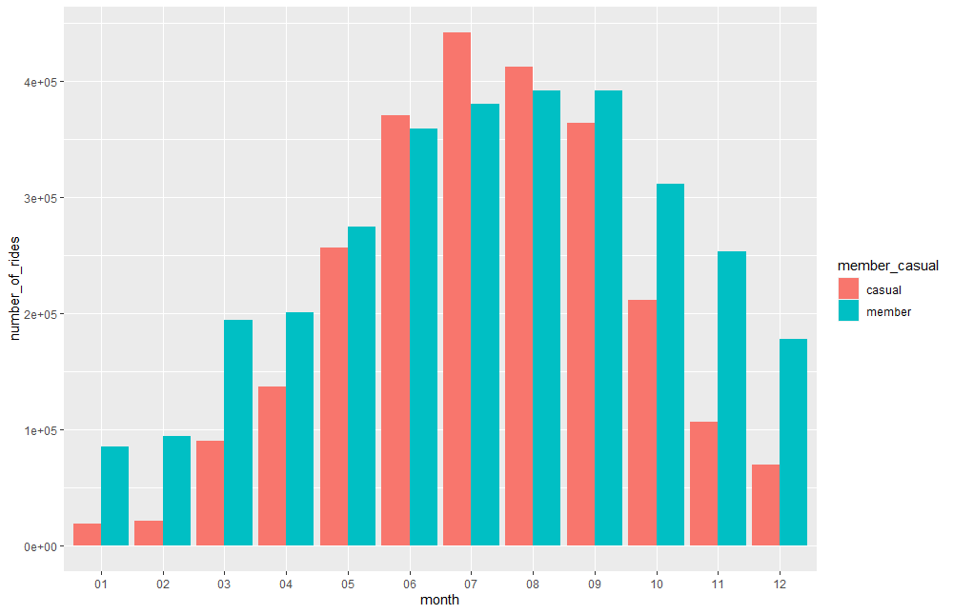

* This graph displays the total number of rides by Month between Casual and Membership Riders
* Casual Riders Total % of Rides: **44.5%**
* Membership Rides Total % of Rides: **55.5%**

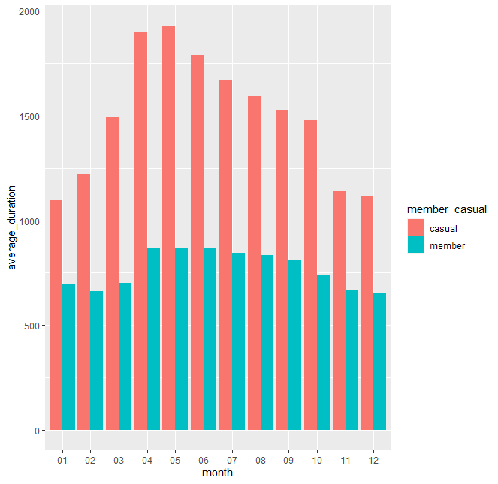

* This visual represents the average duration of rides between casual and membership riders each month. Overall, casual riders generally ride way longer than members.
* Casual Rider Avg Trip Duration: 1689 seconds (28.12 Minutes)
* Member Rider Avg Trip Duration: 793 Seconds (13.2 Minutes)

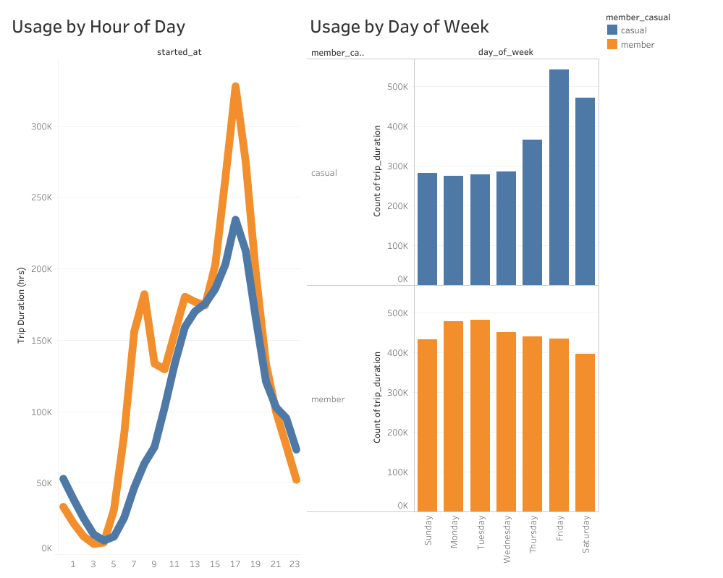

* The total trip duration for members far surpasses that of casual riders, meaning that members ride more frequently and consistently.
* Trips for Members peak in the morning and early afternoon, and then once again in early evening. Casual riders steadily increase in rides throughout the day, peaking in the early evening, and sharply declining thereafter.
* Member riders are generally consistent with their usage, maintaining relatively similar usages throughout the week. On the other hand, casual riders are most active during the weekends.

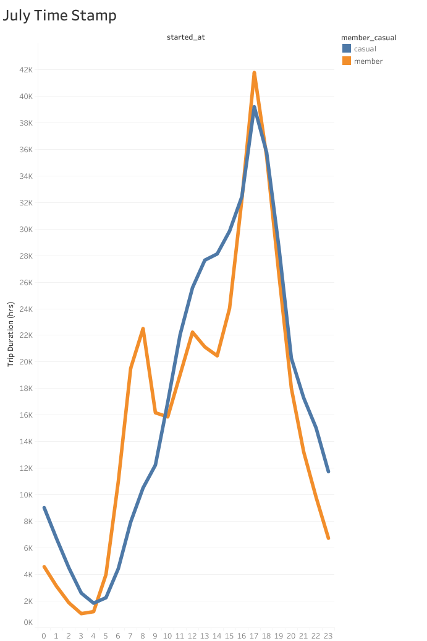

* Details hour by hour total trip duration for each day in July, the most active month of riders between both Members and Casual riders.
* Member riders have two peaks during the day, one during the morning and then again later in the afternoon
* Casual riders rapidly increase in total trip duration throughout the day, as it comes to a peak at 5 PM, and then rapidly dips down.

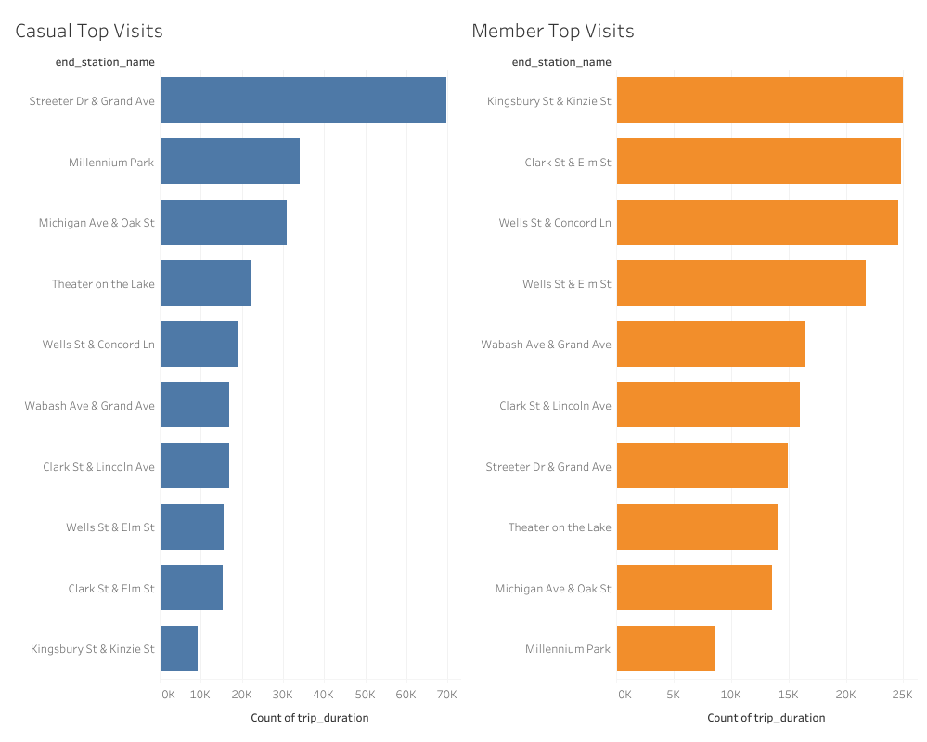

* This visual displays the top 10 end station’s visits between Casual (left) and Member (right) riders
* For Casual riders, an overwhelming number of trips were taken in popular tourist areas such as Streeter Dr and Millennium Park.
* For members, there was a much more even distribution, as the top trips were areas located centrally in the city near office buildings, and some sightseeing areas.
* This data suggests how casual and member riders differ by how they would use Cyclist. Casual riders are more likely to go sightseeing, whereas members are likely using the bicycle program as a part of their daily commute to work, or wherever they need to go on a daily basis.

**Conclusions**

Observing the total trip duration alongside the month of year, reveals general trends for all riders. This information is useful because knowing when in the year to launch a campaign, will increase its effectiveness. For all riders in general, there is a distinct relationship between trip duration and season, whereas in the colder months we see significantly less hours in trip duration. This suggests that during the cold winter months, less people are willing to ride a bicycle, as they are likely much more willing to drive or take public transport. On the other hand, beginning in the spring up until the end of summer, the total trips and trip duration rapidly increases and eventually peaks, as the data reveals that many more people are willing to ride bicycles as a means of transportation when it's warm. Knowing this information about trip duration and time of year, points to the spring / early summer being the most effective time to launch a marketing campaign.

Moreover, this data can also be used to reveal how casual and members differ to help determine the most effective strategy to convert casual riders. First by looking at the time of day and week for trip duration peaks, members display peak periods around 8-11 AM and then again at 5 PM. Their usage is also evenly distributed throughout the week, meaning their activity levels remain consistent throughout the week. To go further, analyzing the most end stations visited by members, there is also a fairly even distribution, and the top places are central areas near office buildings. It can be reasonably inferred that these people are using the bicycles mainly as a part of their daily commutes to work or frequented areas. As for casual riders, their times peak between 1 and 5 PM, and reach peak usage on weekends and Friday. The top end stations visited are also sightseeing areas. Generally, there is far less distribution for casual riders compared to members, with ‘touristy’ areas accounting for a significant amount of the rides. Knowing the time of day, week, and areas frequented by casual riders, suggests that these riders are predominately workers using the service to sightsee on the weekend, tourists, students, or retirees.

**Recommendations for Cyclistic's Marketing Team:**

1. Launch a marketing campaign in the months of April or May until the end of summer where casual riders are most active and likely to use Cyclistic.
2. Offer some type of membership discount to casual riders on weekends since that is when they are also most active.
3. Direct the marketing campaign efforts towards the idea of riding a bicycle as a part of someone’s everyday commute, since that is what many members are using the program for. In other words, promote the joy of riding a bike to work every day and the benefits it can bring. For example, making casual riders aware of the health benefits of riding a bicycle every day, saving money on gas, helping to save the planet, and enjoying the warm weather as you exercise and commute every day. If a casual rider really enjoyed their bicycle trip as a part of their weekend activity, they could be attracted to make it an everyday habit.

# 